OLLAMA
ollama run llama3.2
\bye

POSTGRES
psql -U postgres -h localhost -p 5432
\q to quit
\l list all databases
CREATE DATABASE databasename;
Don’t forget the semicolon
\c databasename (to connect with database)
pgvector

This is where pgvector must be installed:
/Applications/Postgres.app/Contents/Versions/16/share/postgresql/extension/pgvector.control

but you need to tell where postgres files are. The following were done:
export PATH="/Applications/Postgres.app/Contents/Versions/latest/bin:$PATH"
export PG_CONFIG="/Applications/Postgres.app/Contents/Versions/latest/bin/pg_config"
git clone --branch v0.8.0 https://github.com/pgvector/pgvector.git

This is where its installed
/Applications/Postgres.app/Contents/Versions/16/include/postgresql/server/extension/

But still got the error:
Could not open extension control file "/Applications/Postgres.app/Contents/Versions/16/share/postgresql/extension/pgvector.control": No such file or directory.
\dt will list all the tables

COMMANDLINE
$source ~/.zprofile
The above command will instantly help us executing conda and brew commands
similarly
$source ~/.bash_profile
will do the same thing for bash

also there is a file called ~/.zshrc where all the path information is stored.
We use source even on that file. but it doesnt work
$source ~/.zshrc

Also we can switch between the shell by using
$zsh
or
$bash

To configure vim plugins:
Go to
~/.vimrc file and make change sthere

Then go to vim and say :PlugInstall

To use nerdtree just say
:NERDTree

To use fzf

pACKAGES WE NEED IN PYTHON DJANGO
pgvector
psycopg-binary
psycopg
ollama
langchain
langchain_postgres
langchain_huggingface

pipenv uninstall psycopg2

EKS

$brew tap weaveworks/tap
$brew install weaveworks/tap/eksctl
$eksctl version
$brew install awscli

Do above command in local machine.

Now go to AWS and open its CLI
Execute the following command:
$aws configure
Enter the values of the prompt
Two files “config” and “credentials” will be created at
~/.aws/
Now download those files and put it in your local hosts ~/.aws/ folder.
Both of them

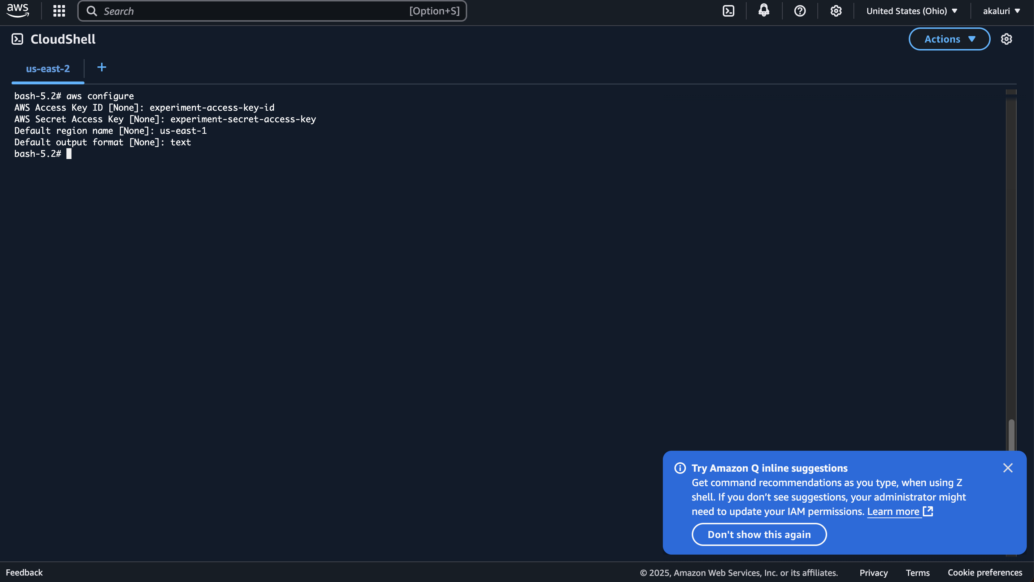

Now this will be stored in
~/.aws/credentials file
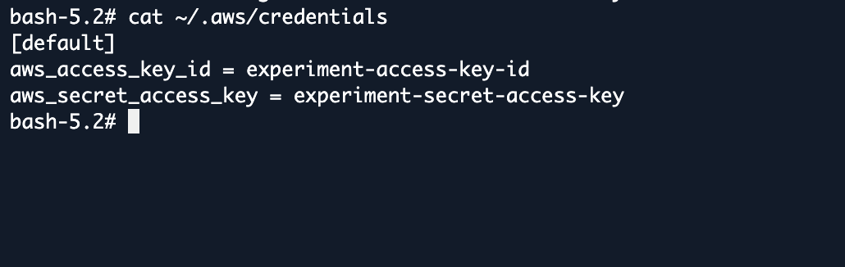

You can download this file

Download the user access key id and secret access key from the IAM for each user.
Then execute:
$aws configure
On your local terminal
Enter these details.

$eksctl create clusterrolebinding sudama-admin-binding \
--clusterrole=cluster-admin \
--user=arn:aws:iam::982534389010:user/Sudama

$aws eks update-kubeconfig --region us-east-1 --name ads-exp-cluster-1

POLICY

Policy= permission associated with identity or resource
- Identity based policies
- Attached to IAM user, group, role
- What that identity can do
- Resource-based policies
- Permission to resource
- WHO HAS ACCESS TO THE RESOURCE AND WHAT ACTIONS

When a request comes first the deny policies is checked and then the allow list.
A user who has specific permissions might request a resource that also has a permissions policy attached to it. In that case, AWS evaluates both sets of permissions when determining whether to grant access to the resource.

PROCEDURE

$aws configure
Configure with your access key id and secret access key

Create public private ssh key:
$ssh-keygen
Passphrase: anirudhkaluri
Your identification has been saved in /Users/anirudhkaluri/.ssh/id_rsa
Your public key has been saved in /Users/anirudhkaluri/.ssh/id_rsa.pub

Then create eks cluster:
$ eksctl create cluster -f ads-eks-cluster.yaml

Now create RDS database instance on the same vpc of the eks cluster with the security group of node group. I also made it publicly accessible.

We were unable to connect to the RDS instance despite adding my public ip to the security group that has been assigned to the rDS. This is the security group of the eks nodegroup.

So I tried connecting ssh to the ec2 instance in the nodegroup. However it didn’t work with ec2 instances which are based on amazonlinux. So I created new node group with ubuntu as the ami.

$ssh -i ~/.ssh/id_rsa ec2-user@100.26.44.180 (for amazon linux 2 ami)
$ssh -i ~/.ssh/id_rsa ubuntu@54.144.107.139 (for ubuntu ami)
Then installed psql. Psql can only be installed on ec2 instances with ubuntu images. Its not getting installed on amazonlinux2 instances.
$sudo apt update
$sudo apt install postgresql
Then executed below command
$psql -h ads-project.cuj8wywaqgqr.us-east-1.rds.amazonaws.com -U adsprojectuser -d vectordb -p 5432
You get connected
Then execute
Vectordb$ CREATE EXTENSION IF NOT EXISTS vector;
Check it by executing
Vectordb$\dx
Now lets delete node groups which used amazonlinux2
You can use the following command to delete a node group
$eksctl delete nodegroup \
--cluster ads-project-eks-cluster \
--name ads-project-nodegroup-3

Now time to push the docker image to ecr.
Create the dockerfile. Note that before creating the docker file the django application has been modified to use environmental variables for database.

Once the dockerfile is ready, authenticate the docker client in your computer to the ecr. For that execute this command
$ aws ecr get-login-password --region us-east-1 | docker login --username AWS --password-stdin 982534389010.dkr.ecr.us-east-1.amazonaws.com
https://docs.aws.amazon.com/AmazonECR/latest/userguide/registry_auth.html
ECR is private, so Docker can’t access it unless you log in. This command:
- Gets a temporary auth token from AWS
- Logs Docker into your ECR registry
- Lets you push/pull images securely

982534389010 is the account id.

Then go to the folder having dockerfile and do
$docker build -t vectorexp .

But we have to build for the linux platform
$docker buildx build --platform linux/amd64 -t vectorexp .
Once the docker image is built:

Finally this worked:
docker build --platform linux/amd64 -t vectorexp .
$docker tag vectorexp:latest 982534389010.dkr.ecr.us-east-1.amazonaws.com/adsproject:latest
$ docker push 982534389010.dkr.ecr.us-east-1.amazonaws.com/adsproject:latest

Now after docker image is ready make the deployment and services for using in nodes.

We are unable to create pods in t2.micro since they are very small. So we are going to use t3.small.

ssh -i ~/.ssh/id_rsa ubuntu@44.199.243.170

$eksctl create clusterrolebinding sudama-admin-binding \
--clusterrole=cluster-admin \
--user=arn:aws:iam::982534389010:user/Sudama

$aws eks update-kubeconfig --region us-east-1 --name ads-exp-cluster-1

How to start shell in Kubernetes worker nodes:
$kubectl exec -it <your-pod-name> -- /bin/bash

#getting cpu usage
$kubectl top node

#EKSCTL COMMAND FOR AUTOSCALING:

eksctl scale nodegroup --cluster=<clusterName> --nodes=<desiredCount> --name=<nodegroupName> [ --nodes-min=<minSize> ] [ --nodes-max=<maxSize> ] –wait

eksctl scale nodegroup --cluster=ads-project-eks-cluster --nodes=15 --name=ads-project-nodegroup-m6 --nodes-min=5 --nodes-max=15 --wait

#if any node is down run this command
kubectl describe node ip-192-168-39-97.ec2.internal

#deleting a node
kubectl delete node ip-192-168-39-97.ec2.internal

#see if kubelet is running in a node
First ssh into that node and execute
$sudo systemctl status kubelet

#configuring your kubectl in your laptop
$aws eks update-kubeconfig --region us-east-1 --name ads-project-eks-cluster

#scaling down or up the deployments
kubectl scale deployment/vectorexp-deployment --replicas=2

- name: ads-project-nodegroup-5
instanceType: t3.large
desiredCapacity: 2
amiFamily: Ubuntu2204
ssh:
allow: true
publicKeyPath: ~/.ssh/id_rsa.pub

- name: ads-project-nodegroup-m6
instanceType: m6i.xlarge
desiredCapacity: 4
amiFamily: Ubuntu2204
ssh:
allow: true
publicKeyPath: ~/.ssh/id_rsa.pub

apiVersion: apps/v1
kind: Deployment
metadata:
name: vectorexp-deployment
spec:
replicas: 1
selector:
matchLabels:
app: vectorexp
template:
metadata:
labels:
app: vectorexp
spec:
containers:
- name: vectorexp-container
image: 982534389010.dkr.ecr.us-east-1.amazonaws.com/adsproject:latest
ports:
- containerPort: 8000
env:
- name: DJANGO_SECRET_KEY
value: django-insecure-01p9#y$@+pv2)=nhg%=8r&tk(m=#!810qjr^ci0+g(9_l#avv%
- name: DB_NAME
value: vectordb
- name: DB_USER
value: adsprojectuser
- name: DB_PASSWORD
value: adsprojectpassword
- name: DB_HOST
value: ads-project.cuj8wywaqgqr.us-east-1.rds.amazonaws.com
- name: DB_PORT
value: "5432"
- name: OLLAMA_NO_CUDA
value: "1"
- name: MODEL_NAME
value: "smollm:135m"
- name: IS_PRODUCTION
value: "true"
resources:
requests:
cpu: "3"
memory: "10Gi"
limits:
cpu: "4"
memory: "14Gi"

To use nvide gpu use this command:

kubectl apply -f https://raw.githubusercontent.com/NVIDIA/k8s-device-plugin/v0.14.1/nvidia-device-plugin.yml

verify it using
kubectl get daemonset -A | grep nvidia

